**Warehouse Management System**

**Introduction to Programming**

**CMPT 120L**

**Cache Me If You Can**



Marist College

School of Computer Science and Mathematics

Submitted To:

Dr. Reza Sadeghi

Date: Fall 2024

**Table of Contents**

Table of Figures…...………….....…..……………………………………………………………………….……....…3 Project Descriptions ………...………………………………………………………………..…………..…………..4-5 Github Link…...……………..……………………………………………………………………………….……....…5 User Experience Design……………………………………………………………………………………………6-15 Virtural Environment………………………………………………………………………………………………….16 Login Page…………………………………………………………………………………………………………….17 Main Menu…………………………………………………………………………………………………………….18 Regular User search…………………………………………………………………………………………………...19 View Favorites Page.……………………………….…………………………………………………………………20 User buy/borrow function……………………………………………………………………………………………..21 User View History…….……..………………………………………………………………………………………..22 Admin View borrow requests…….……….…………………………………………………………………………..23 Create Guest User…...……………………………………………………………………………………..………….24 Second Half of Admin Warehouse Management…………………………………………………………..………….25 Admin Remove User...……………………………………………………………………………………..………….26 Admin Create Guest User…...……………………………………………………………………………..………….27 Data Storage…...…………………………………………………………………………...……………..……….28-29

**Table of Figures**

Figure 1 Login Page Flowchart...………...…..………………………………………………………………...………6 Figure 2 Main Menu Flowchart…………………………………………………………………………………...……7 Figure 3 Regular User Search Flowchart……………………………………………………………………………….8 Figure 4 Regular User View Favorites Flowchart……………………………………………………………………9 Figure 5 Buy or Borrow Flowchart……………………………………………………………………………………10 Figure 6 View History Flowchart……………………………………………………………………………………..11 Figure 7 View Barrow Request……..…………………………………………………………………………………12 Figure 8 Manage Warehouse…………..…………………………………………………………………….………..13 Figure 9 Remove User…………………….…………………………………………………………………………..14 Figure 10 Create Guest User…………………………………………………………………………………………..15 Figure 11 CMD installing virtualenv………………………………………………………………………………….16 Figure 12 Virtual Environment being created and then run in VS code………………………………………………16 Figure 13 loadUser function, saveUser function, setupGui function…………………………………………………17 Figure 14 Register function………………………………………………………………………………..………….17 Figure 15 Login function………………………………………………………………………………..…………….17 Figure 16 showMenu function………………………………………………………………………………………...18 Figure 17 Regular User Search …………….…………………………………………………………………………19 Figure 18 viewFavorites function………………………..………………………..………………………..…………20 Figure 19 Buy and Borrow functions.………………………………….……………………………………………..21 Figure 20 User view history………………..………………………………………………………………………….22 Figure 21 First half of Admin View Borrow Code………………………………………………………………….23 Figure 22 Second half of Admin View Borrow Code……………………………………………………………….23 Figure 23 First half of Admin Manage Warehouse………..………………………………………………………….24 Figure 24 Second half of Admin Manage Warehouse……………………………………………………………….25 Figure 25 Admin Remove User………………….………………………….……………………………………….26 Figure 26 First half of Admin Create Guest User………………………………………………………………….27 Figure 27 Second half of Admin Create Guest User………………………………………………………………….27

**Project Description**

PROJECT TITLE: WAREHOUSE MANAGEMENT SYSTEM

**Summary:** THE WAREHOUSE MANAGEMENT SYSTEM (WMS) PROVIDES AN ORGANIZED WAY OF STORING DIFFERENT PRODUCTS AND ELEMENTS IN A WAREHOUSE. YOU CAN CONSIDER A LIBRARY AS A WAREHOUSE, WHICH MAINTAINS BOOKS’ DETAILS AND USER LIBRARIES. A GENERAL WMS STORES DETAILS OF NAME AND IDENTIFICATION NUMBER OF PRODUCTS, THEIR STORE TIME, THE REQUIRED STORAGE CONDITION, PRICE, WEIGHT, HEIGHT, ETC. FOLLOWING THIS, THIS SYSTEM ALLOWS GUEST USERS TO SEARCH FOR DIFFERENT CONTENT AND REQUEST TO BORROW/BUY THEM. YOUR WMS WILL STORE THE DATA OF DIFFERENT USER TYPES IN DISTINCT COMMA SEPERATED VALUE (CSV) FILES. THIS SYSTEM SHOULD AT LEAST SUPPORT THE FOLLOWING ITEMS:

1. ADMIN USER IS CAPABLE OF:

a. HAVING ADMIN USER AND PASSWORD FOR LOG IN (A STRING OF AT LEAST 8 CHARACTERS)

b. CHANGING THE ADMIN USER AND ADMIN PASSWORD

c. ADDING A GUEST USER TO WMS BY CREATING A NEW USERNAME AND PASSWORD. A GUEST USER IS NOT ABLE TO DEFINE OR REMOVE OTHER USERS.

d. REMOVING USERS FROM WMS BY REMOVING THEIR USERNAME, PASSWORD, AND CORRESPONDING RECORDED DATA.

e. ADDING AN ITEM TO THE WAREHOUSE WITH VARIED DETAILS, SUCH AS:

i.TYPE: FOOD, BOOKS, CARS, ETC.

ii.STORED TIME IN THE WAREHOUSE

iii.PICK OUT TIME FROM THE WAREHOUSE

iv.ID: EACH ITEM IN YOUR LIBRARY SHOULD HAVE A

UNIQUE IDENTIFICATION NUMBER WITH A SPECIFIC

FORMAT

v.NAME

vi.PROVIDER/CREATOR’S NAME

vii.QUANTITIES: THE NUMBER OF AVAILABLE ITEMS. FOR

INSTANCE, ITEM X WITH A QUANTITY OF 2 IS A SIGN OF 2

AVAILABLE X ITEMS IN YOUR WAREHOUSE.

viii.PLACE: WHERE THE ITEM IS STORED

ix.PRICE.

f. DELETING AN ITEM FROM WAREHOUSE

g. EDITING AN ITEM IN WAREHOUSE

h. VIEWING THE LIST OF BORROWING REQUESTS

i. ACCEPTING OR REJECTING A BORROWING REQUEST

2. EACH USER SHOULD BE ABLE TO:

a. SEARCH THROUGH WMS BASED ON ALL ITEMS’ DETAILS,

SUCH AS ID, NAME, AND PRODUCER.

b. SAVE A LIST OF FAVORITE ITEMS

c. REQUEST TO BORROW/BUY SOME ITEMS FOR A SPECIFIC

TIME. FOR EXAMPLE, BORROWING ITEM A FOR 3 WEEKS.

d. VIEW THE HISTORY OF BORROWED ITEMS

3. WMS SHOULD BE A USER-FRIENDLY SOFTWARE, SUCH THAT: a. IT SHOWS A WELCOME PAGE

b. IT PROVIDES A MENU OF ALL FUNCTIONS TO THE USER IN ALL PAGES

c. IT ILLUSTRATES THE REPORTS IN A TABULAR FORM. FOR INSTANCE, IT DISPLAYS A WELL-ORGANIZED LIST OF THE REQUESTED ITEMS.

d. WMS SHOULD PROVIDE AN EXIT FUNCTION AND THANK THE USER FOR USING THIS SOFTWARE.

e. IT SHOWS A WARNING IF:

i.THE ADMIN USER TRIES TO ADD A NEW ITEM TO THE

LIBRARY WITH AN EXISTING ID.

ii.IF A GUEST USER TRIES TO BORROW MORE THAN 3 ITEMS.

iii.A USER SEARCH REQUEST RETURNS NULL ITEMS.

4. WMS SHOULD PROTECT THE USER INFORMATION, SUCH THAT: a. OPTIONAL: WMS PASSWORDS AND THE RECORDED INFORMATION SHOULD BE CIPHERED. IN THE SIMPLEST CASE, YOU CAN USE CAESAR CIPHER METHODOLOGY. THE EASIEST WAY TO UNDERSTAND THE CAESAR CIPHER IS TO THINK OF CYCLING THE POSITION OF THE LETTERS. IN A CAESAR CIPHER WITH A SHIFT OF 3, A BECOMES D, B BECOMES E, C BECOMES F, ETC. WHEN REACHING THE END OF THE ALPHABET IT CYCLES AROUND, SO X BECOMES A, Y BECOMES B, AND Z BECOMES C.

GitHub Link: <https://github.com/Bomb321/CMPT120_Project-4_Cache-Me-If-You-Can>

Login Page:

Input: Username and Password in text

Output: Valid username and password enable the user to move onto the main menu. If the username and password match the admin username and password, the user will be taken to a menu where they may change the admin password, or proceed to the admin main menu . If the password is invalid, a message is displayed informing the user that their information is invalid, and prompts them to log in again.

*Figure 1 Login Phase Flowchart [1]*

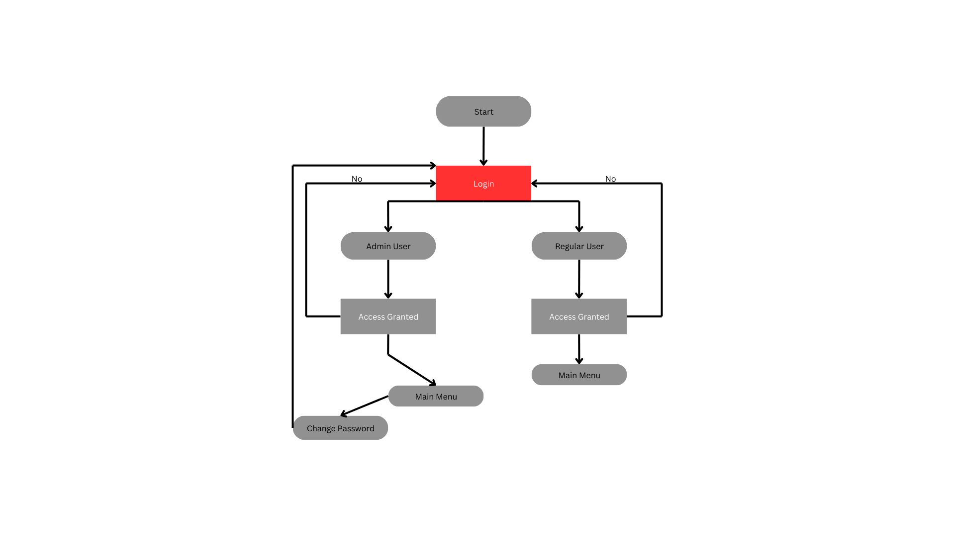

Main Menu:

Input: User will be provided with a list of options which will change depending on if the user used Admin or Regular login credentials. User will pick one option

Output: User will be taken to another page corresponding to the option they choose.

*Figure 2 Main Menu Flowchart [2]*

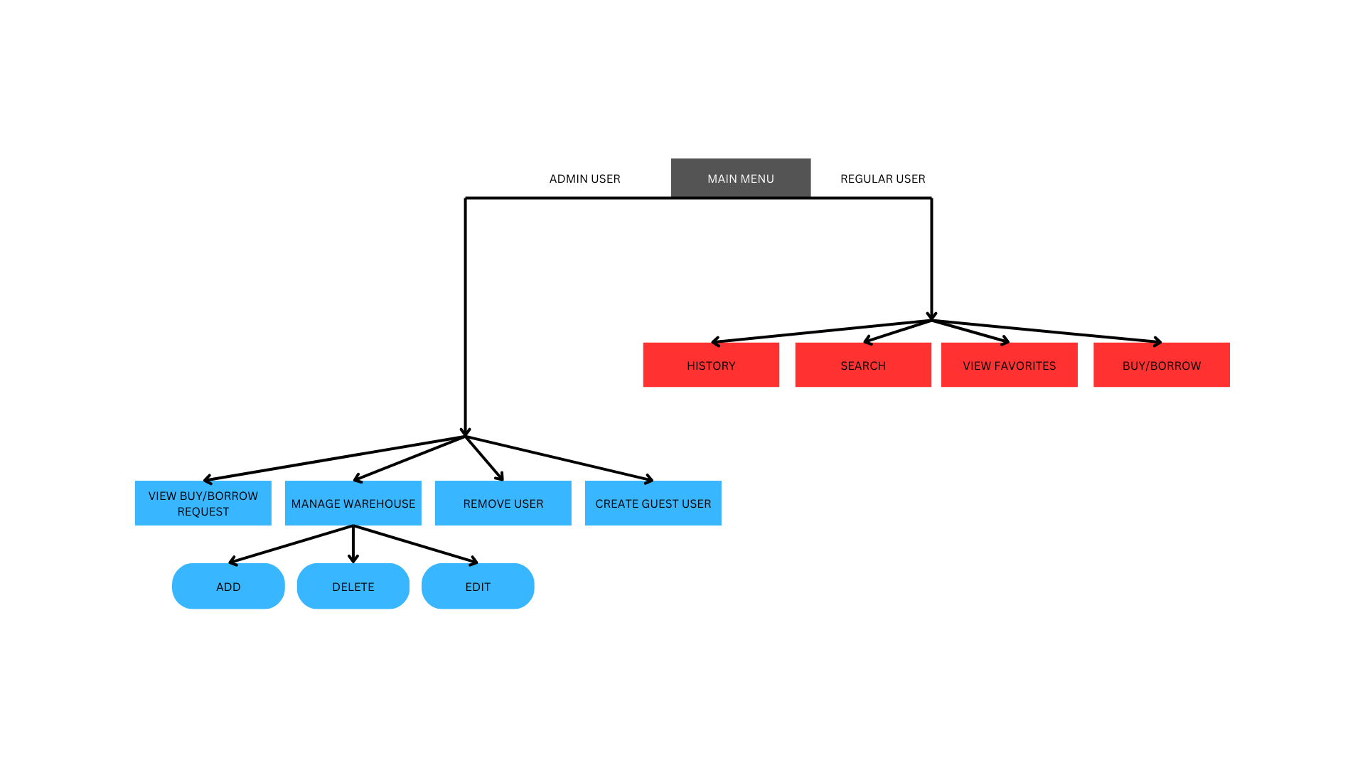

Regular User Search:

Input: Users will be prompted to choose if they want to search by ID, Product Name, or Producer. Then they will be prompted to search. After the output is provided, the user will also be prompted to add the item to their favorites list. Afterwards, they will be asked if they want to search again.

Output: A list of products, and follow up prompts asking for further inputs. If the user does not want to search again, they will be taken back to the regular user main menu,

*Figure 3 Regular User Search Flowchart [3]*

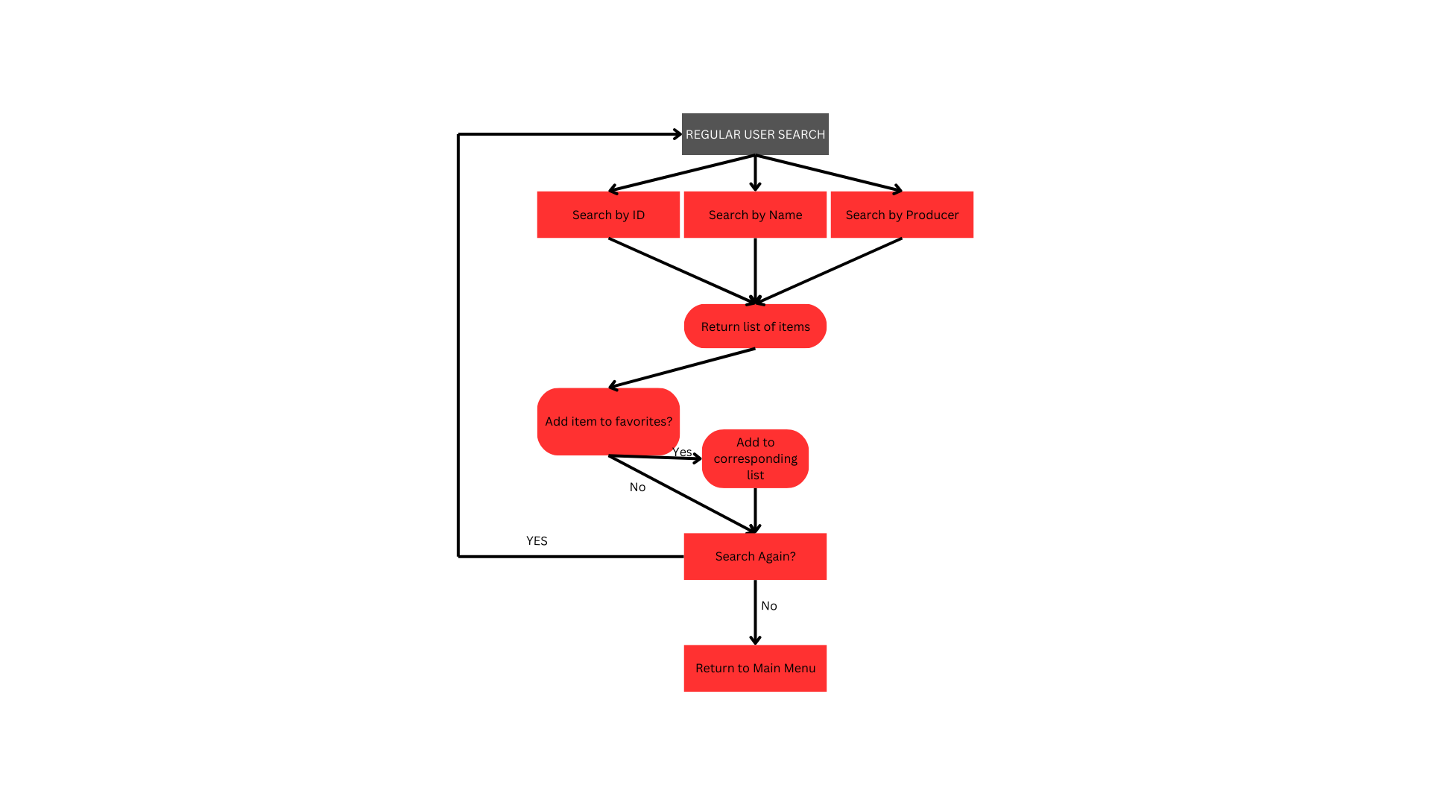

Regular User View Favorites

Input: Users will be prompted to return to the main menu.

Output: Users will be presented with a list of items in their favorite list.

*Figure 4 View Favorites Flowchart [4]*

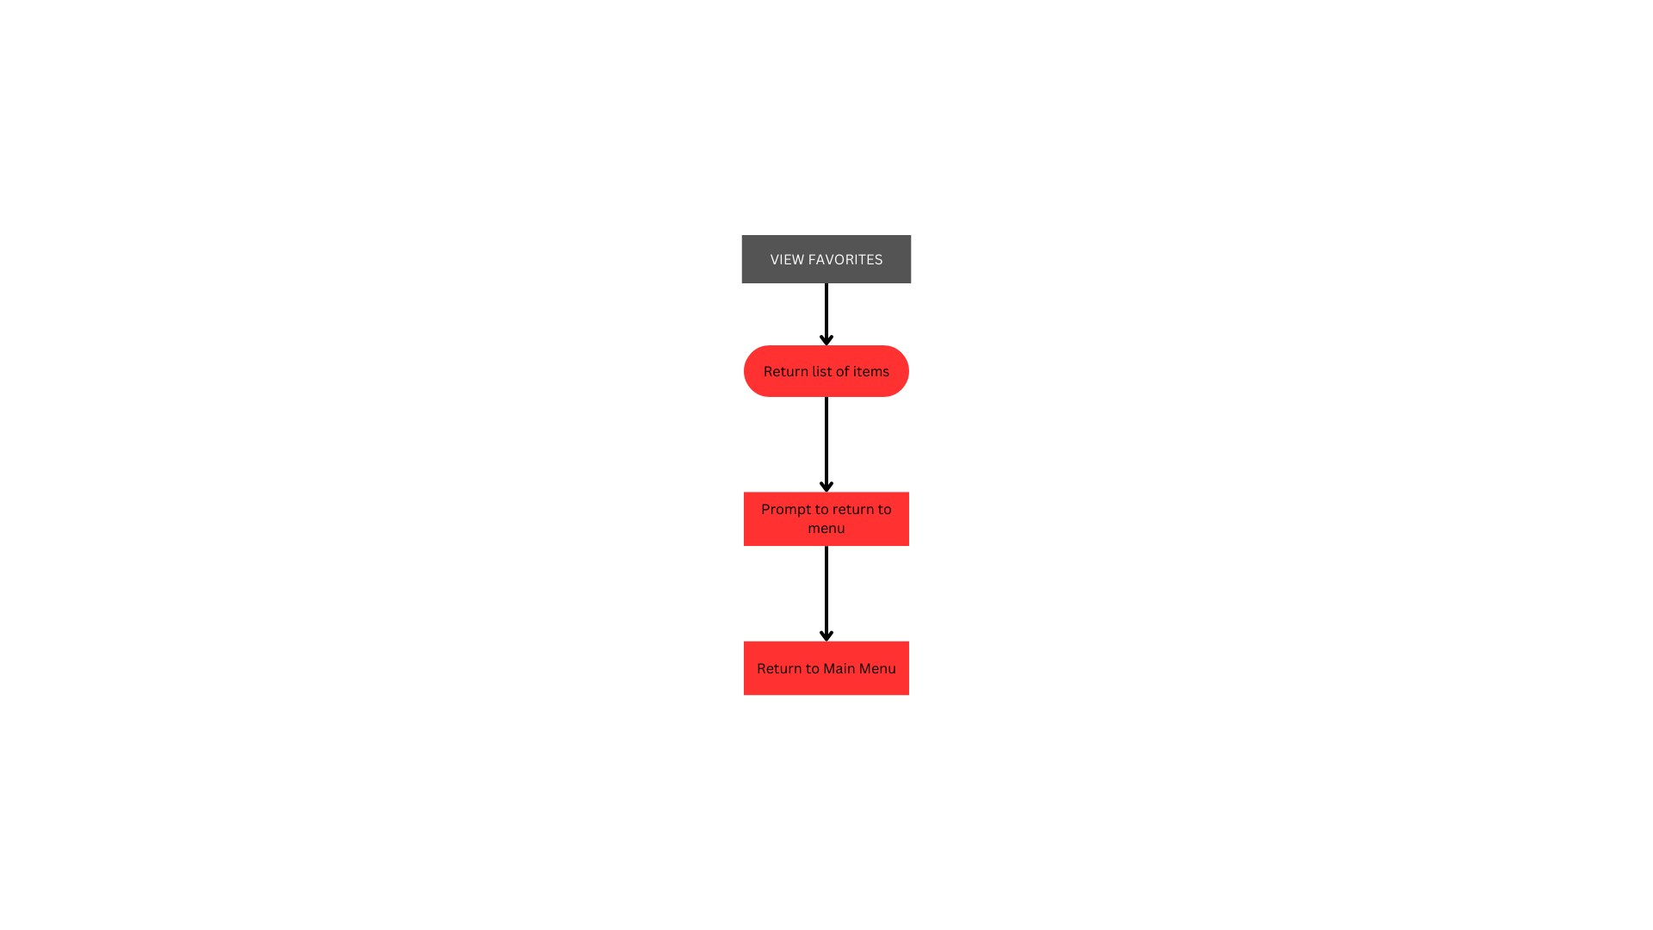

Regular User Buy or Borrow

Input: Users will be asked to provide the name of the product, if they are buying or borrowing it, and the duration of their borrowing. Users will also have the option to return to the main menu.

Output: List of items on the buy list presented after each item is added. Follow up questions are also part of output. If the product item is invalid, the user will be redirected to the first output.

*Figure 5 Buy or Borrow Flowchart [5]*

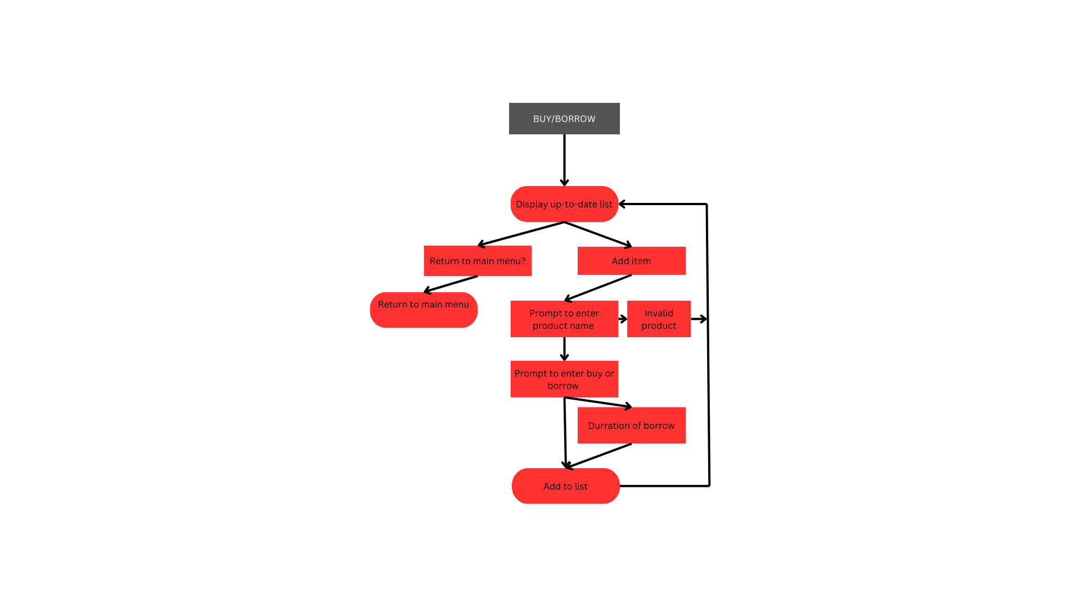

Regular User View History

Input: User will be prompted to return to the main menu after the list is read.

Output: List of all purchases or borrows, and a prompt to return to the main menu.

*Figure 6 View History Flowchart [6]*

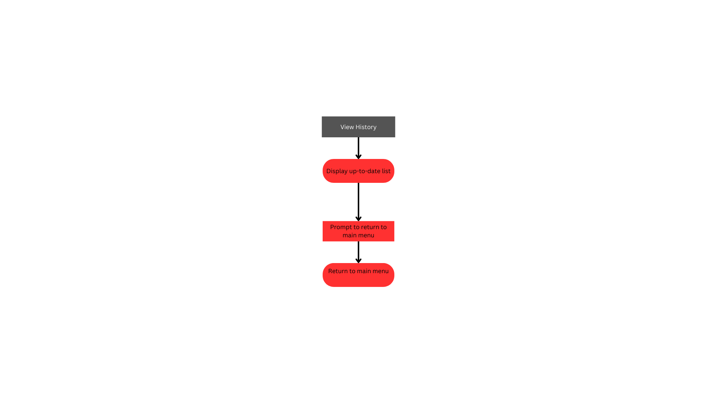

Admin View Borrow Request:

Input: The admin will be asked to search the list of all items requested to be borrowed to find specific requests. They will either accept or reject the request and be prompted to return to the main menu or review more requests.

Output: If rejected, the request will be removed. If accepted, the request will be approved and moved into warehouse management.

*Figure 7 View Barrow Request [7]*

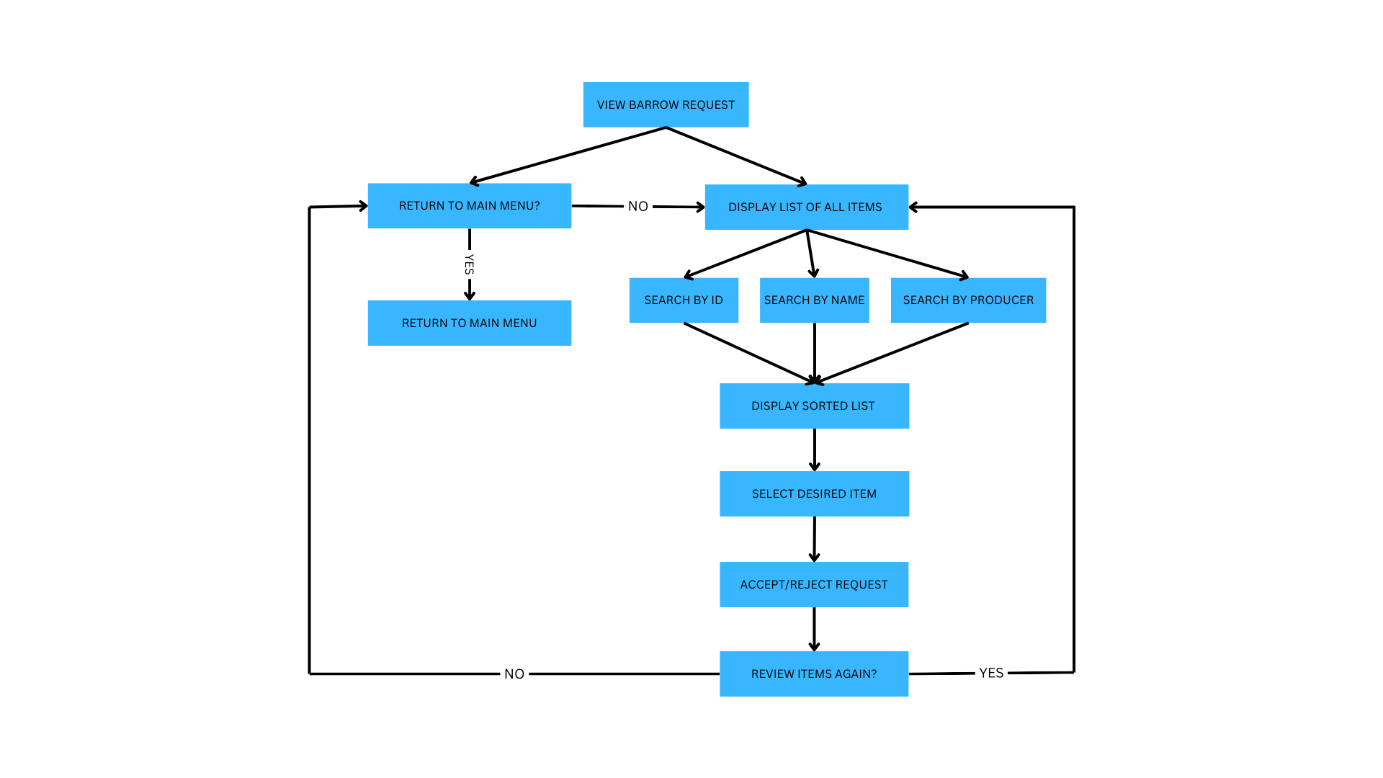

Admin Manage Warehouse:

Input: The admin will be prompted to add, delete, or edit an item from the warehouse. For accuracy, all three actions will require the product's name, ID, and producer before updating the list and prompting the admin to return to the main menu or adjust the warehouse again.

Output: The warehouse list will be updated for the regular user to view

*Figure 8 Manage Warehouse [8]*

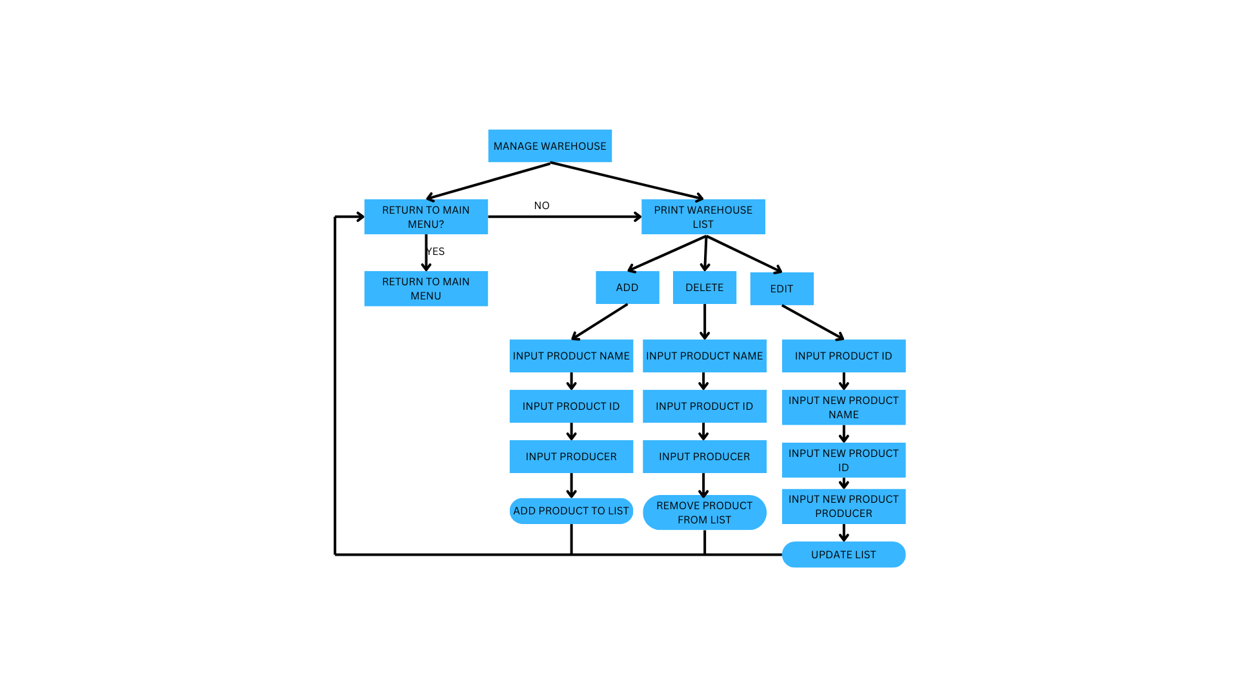

Admin Remove User:

Input: The admin will input the username and password of the desired user to remove before being prompted to confirm the removal of the user

Output: The desired user will be removed along with all of their corresponding data

*Figure 9 Remove User [9]*

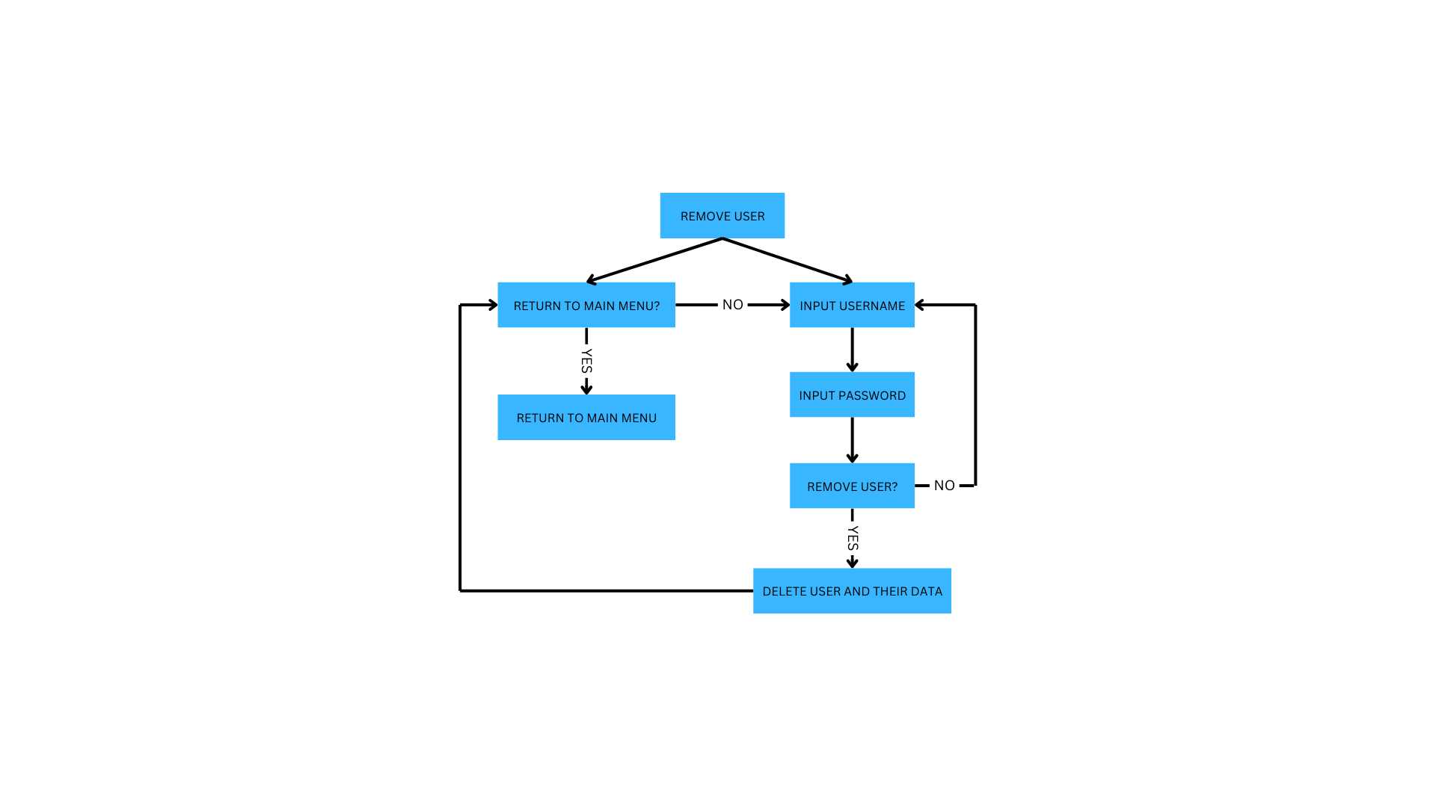

Admin Create Guest User:

Input: The admin will input a new username and password for the corresponding username

Output: New guest user created, returning to the login page for the new user to log in

*Figure 10 Create Guest User [10]*

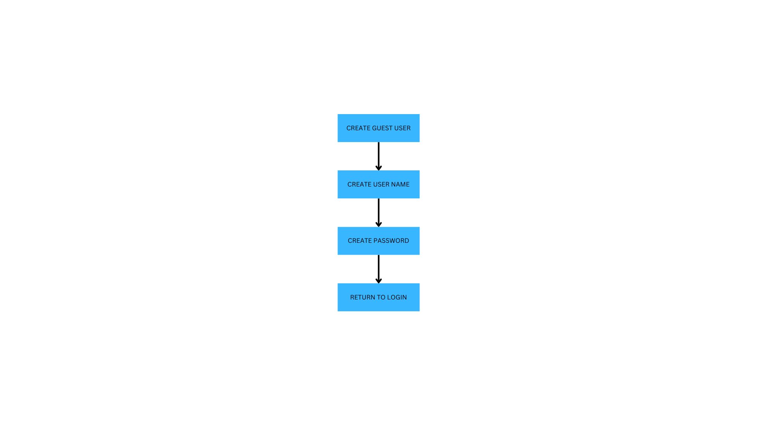

Ensure that virtualenv is installed/ install virtualenv using pip (installed with [python](https://www.python.org/))

*Figure 11 CMD installing virtualenv [11]*

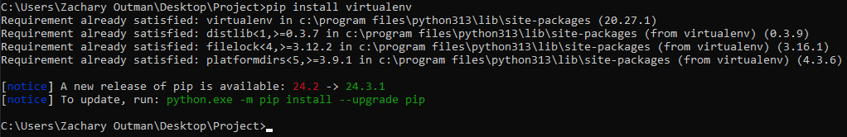

List of packages:  
pip

virtualenv

Venv

Tkiner

Messagebox(From Tkiner)

os

csv

Running a virtual environment in an IDE (VS Code)

*Figure 12 Virtual Environment being created then run in VS Code [12]*

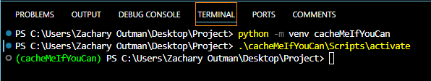

Login Page: The Login Page allows users to input a username and password for authentication. If the credentials are correct, a success message is shown, and the user is directed to the Main Menu. If incorrect, an error message is displayed. Users can also register new accounts via the registration window, which adds the credentials to the system.

*Figure 13 loadUsers function, saveUsers function, setupGui function*

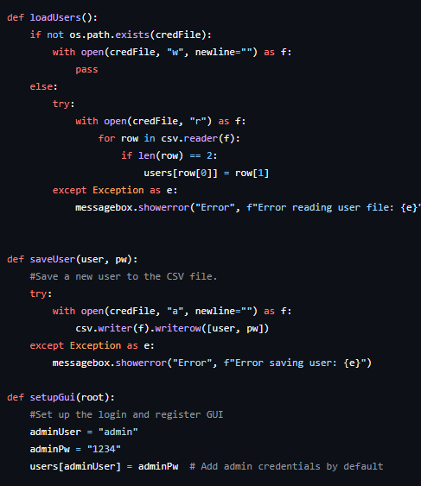

*Figure 14 register function*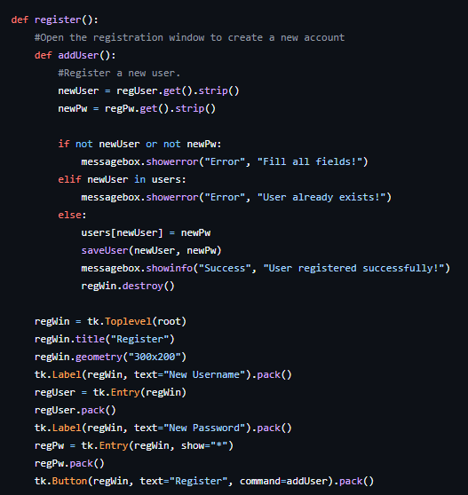

*Figure 15 login function*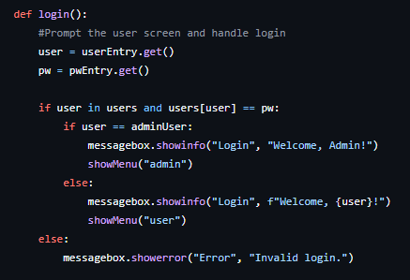

Main menu: The Main Menu dynamically changes based on the user type (admin or regular user), displaying relevant options as buttons. Clicking a button triggers a confirmation message indicating the selected option. The Login Page handles user authentication and registration, while the Main Menu serves as the application's navigation hub.

*Figure 16 showMenu function*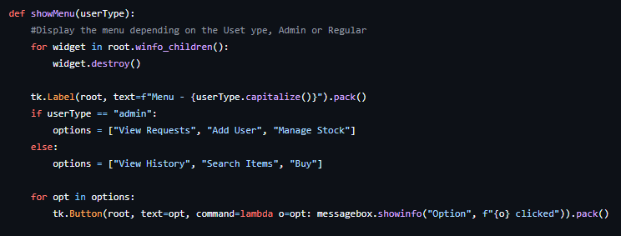

Regular User search

The userSearch page allows regular users to search for items in "userData.csv" file by ID, Name, or Producer and display the results in a list box. Users can also add selected items to a favorites list, which is saved in favorites.csv. It includes buttons for performing a search, adding items to favorites, clearing the search, and returning to the main menu.

*Figure 17 regular user search.*

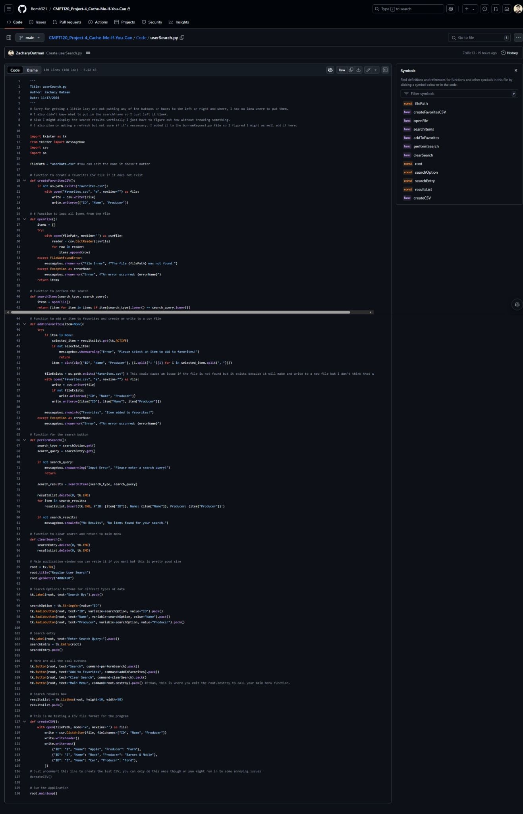

View favorites:

The view favorites page lets users view the items saved by product name, product ID, and product producer during the regular user search. The user is initially prompted by the program to either confirm that they wish to view their favorite products or to return to the main menu. Currently, the main menu function only breaks the program but will return the user to the main menu when we update it in phase 4.

*Figure 18 viewFavorites function*

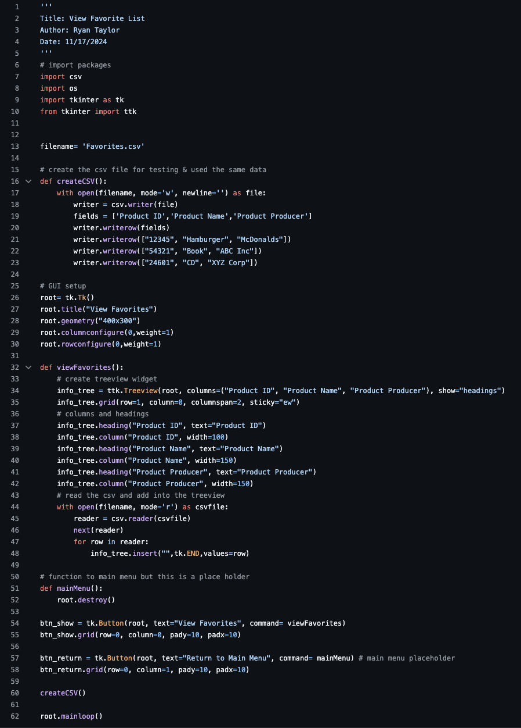

User Buy/Borrow

For user simplicity, this function is within the greater search function. A user is presented with an option to add a selected item to their buy or borrow list. They are then asked if they would like to buy or borrow it, and if they wish to borrow it, they are asked the duration of the loan. These results will then be written to 2 files, the borrow list that can be viewed by the admin, and the history list that is viewable by the user.

*Figure 19, buy and borrow functions*

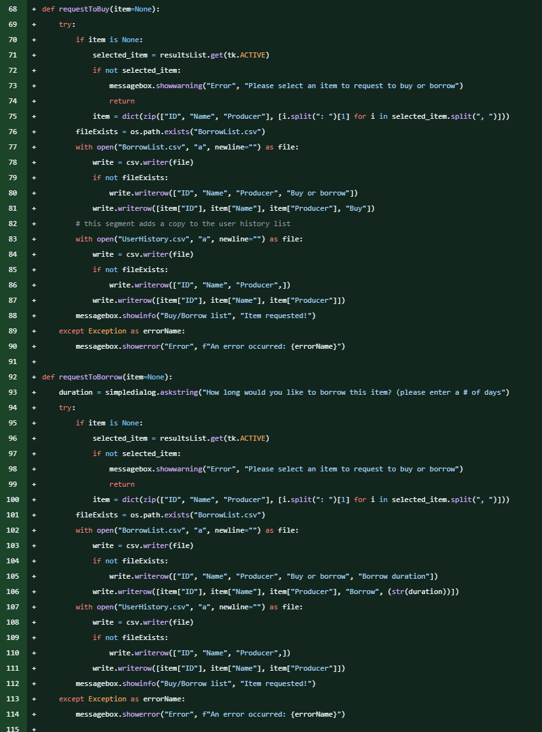

View History

The view history page is presented in a tree view, where users see a copy of all items they’ve requested to borrow or buy. There is nothing to do on this page other than view the history. There is a button to return to the main menu. The code creates a CSV file for testing purposes – when the code is put together, the writing of this CSV file will occur when the user requests to borrow or buy an item.

*Figure 20, User view history.*

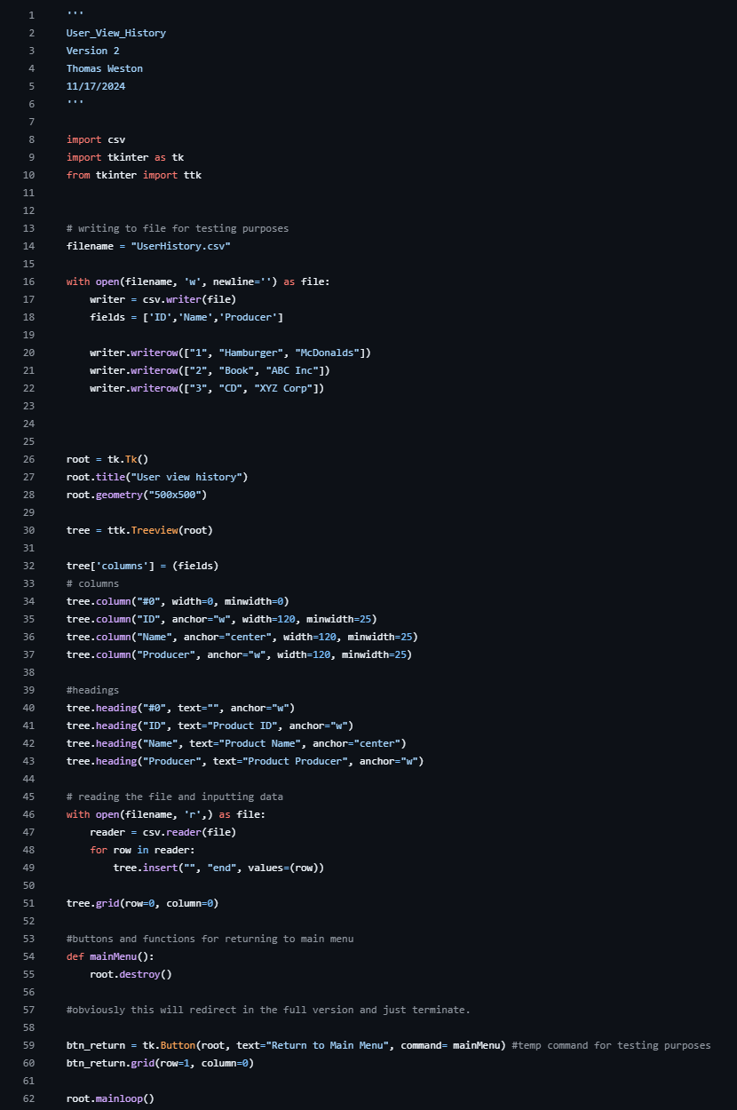

Admin View borrow requests

The Admin view Borrow Requests page presents a tree view where administrators can see all borrow requests from a CSV file called "borrowRequests.csv". Admins can accept or reject requests to borrow from the application. It includes buttons for accepting, rejecting, and refreshing the list of requests, as well as a search functionality to filter requests by ID, Name, or Manufacturer. There is also a button to return to the main menu.

*Figure 21 first half of Admin View Borrow code*

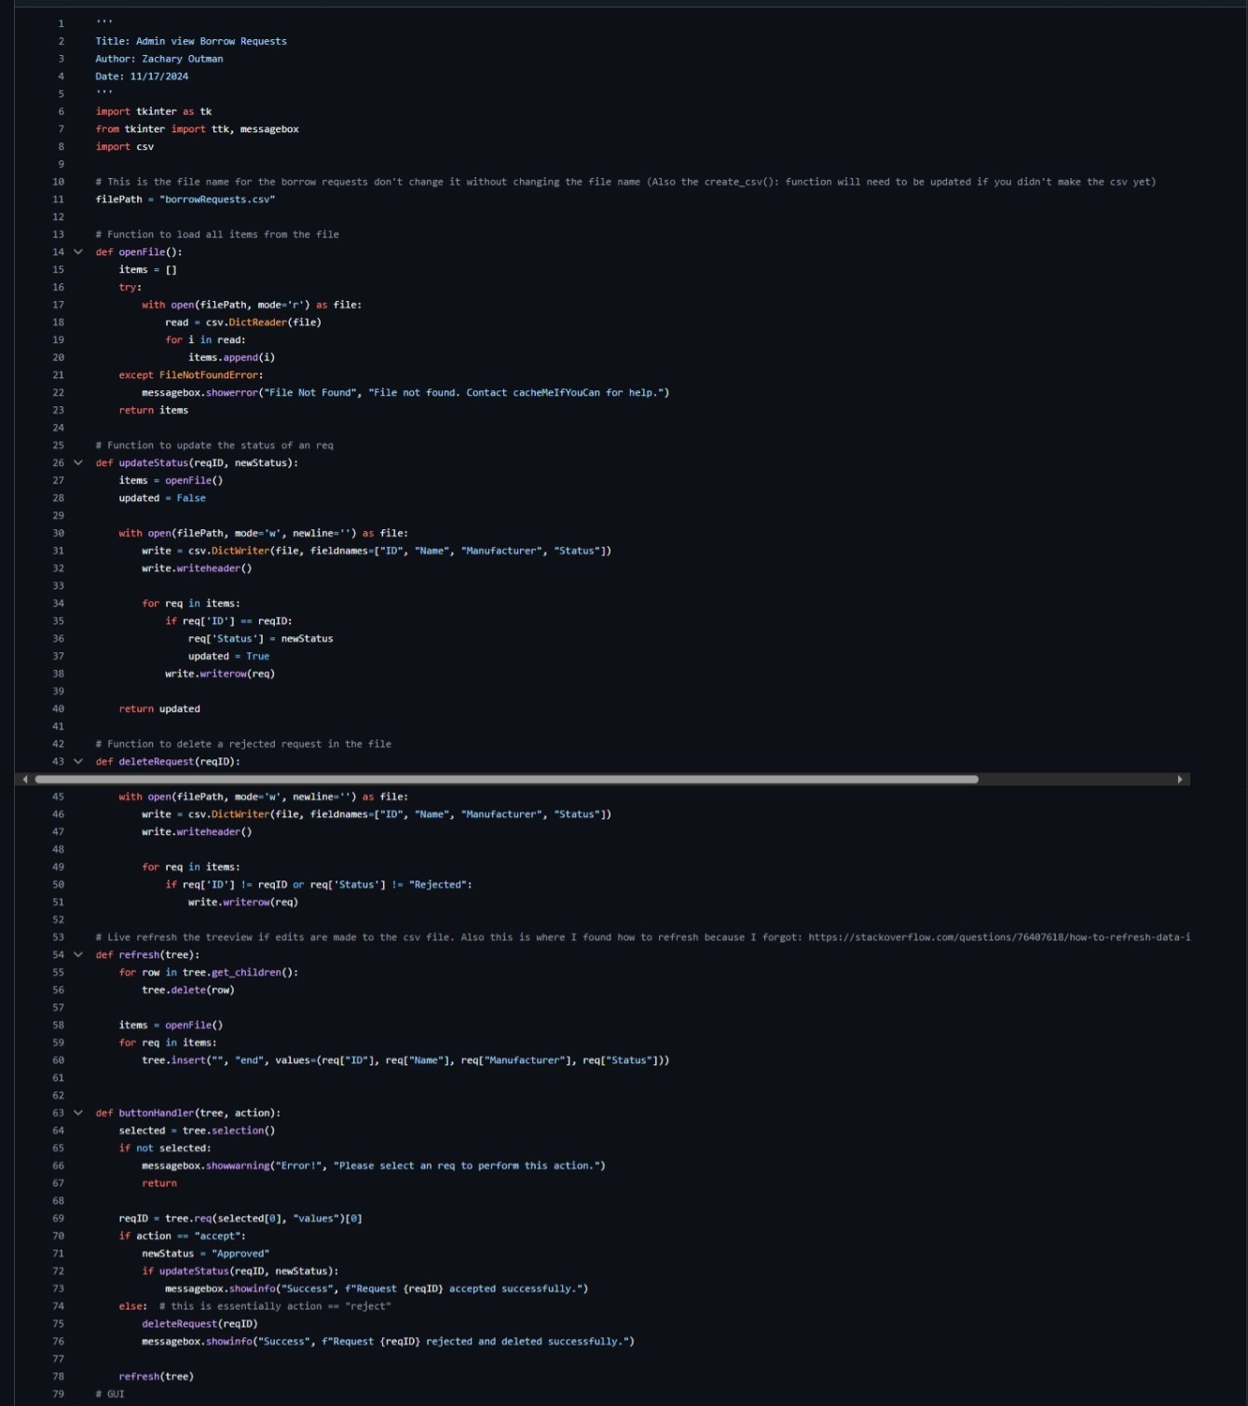

*Figure 22, second half of admin view borrow code*

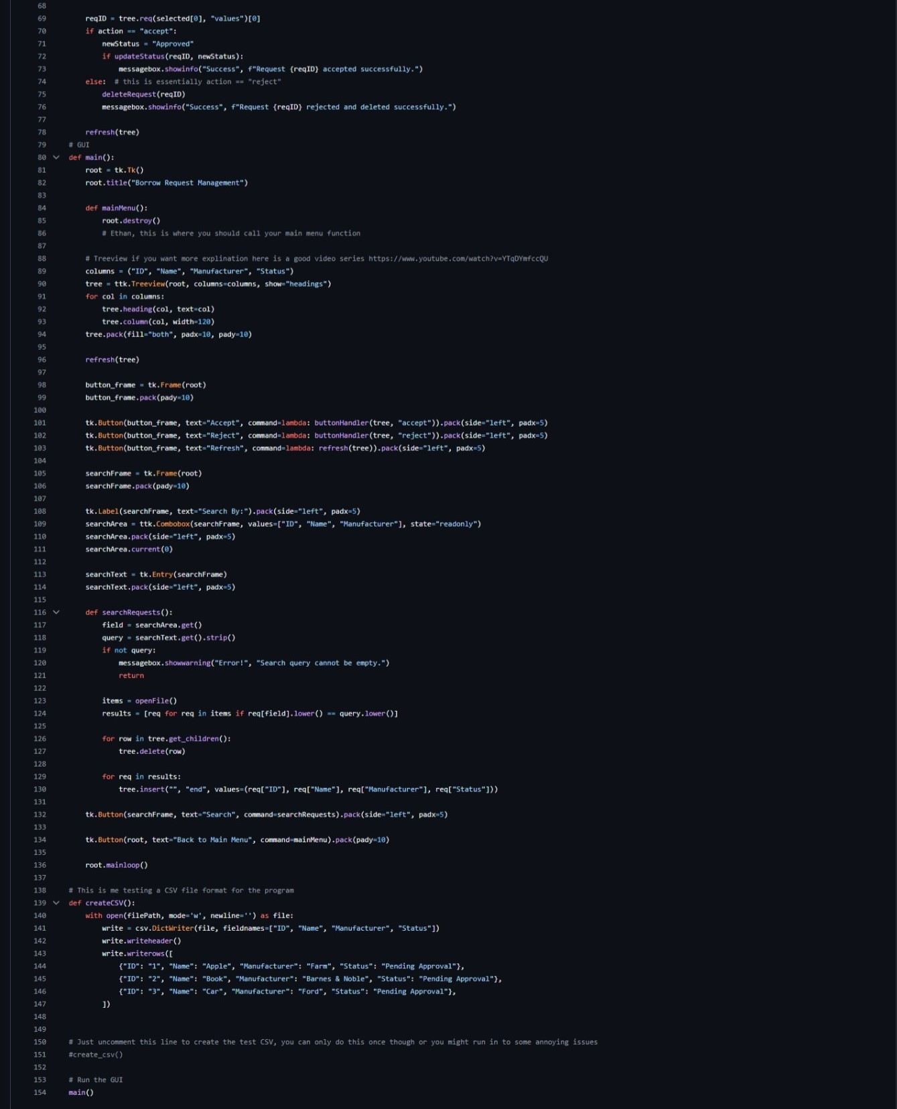

Admin manage warehouse

On program start it opens an example main menu page on program start allowing you to view a basic product list and open the warehouse management panel if you are an admin. Then if you open the warehouse management page you see four columns, product ID, product name, product producer, and new product ID for the warehouse edit function. You can enter any product details to add a product and then press add if a product with the same ID does not exist and the given ID is an integer. To delete you enter the product details including the product ID, name, and producer, and it will delete the product from the warehouse. However, if a product with those details does not exist a message saying such will display. To edit an item you enter the new name in the product name entry, put the product ID of the product you want to change in the product ID entry, enter the new producer, and finally, enter the new product ID. Also after each function the new updated list is displayed.

*Figure 23, first half of Admin Manage Warehouse.*

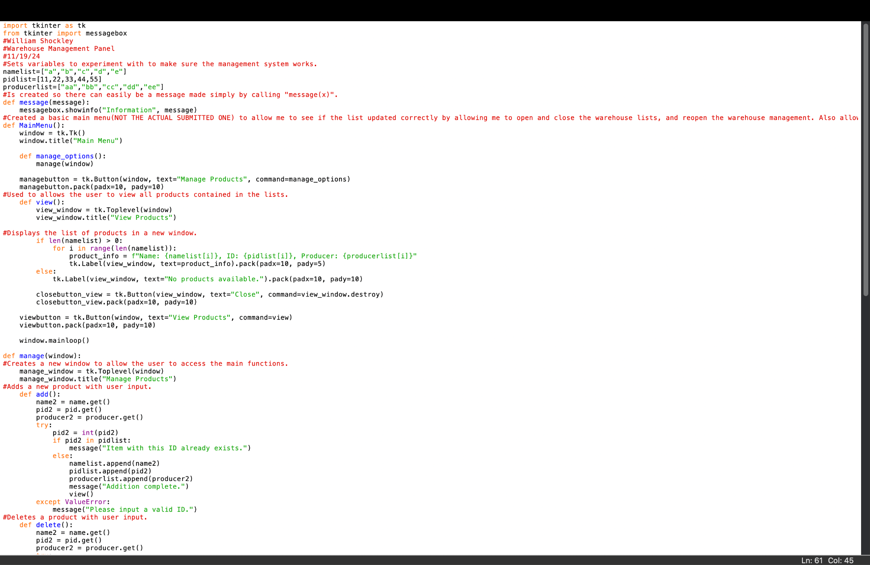

*Figure 24, second half of Admin Manage Warehouse*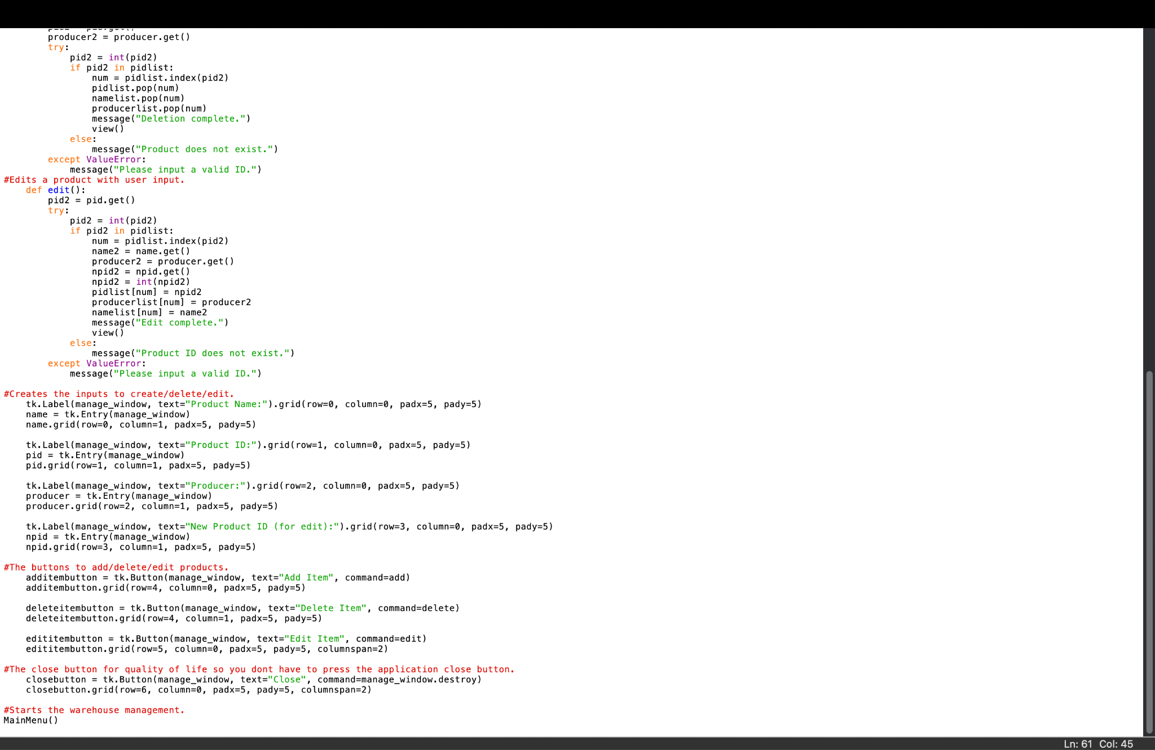

Admin remove user

Open an example main menu where you can open the user removal page. On the user removal page, you can see the names of the current users by pressing the “View Users” button, or you can enter a username and password to remove any non-admin user. If a user is an admin it will return that an admin cannot be removed. The password you enter is shown as * for privacy purposes, it will return if a user does not exist or if the password you entered is incorrect. If you enter a guest user's name and password it will return that the user was removed and they will no longer be visible on the userlist.

*Figure 25, Admin remove user.*

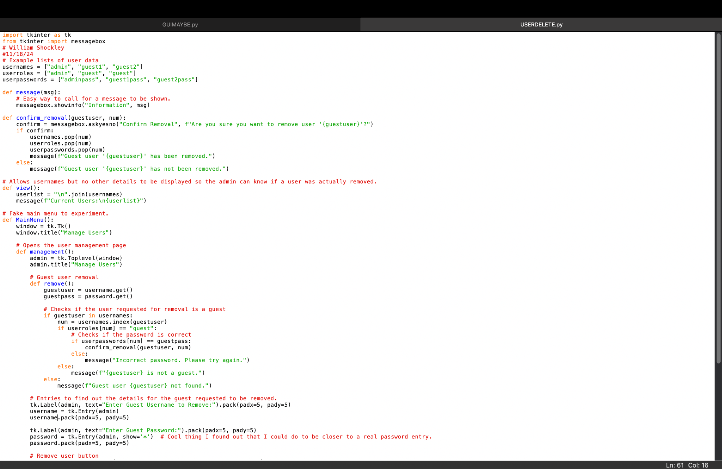

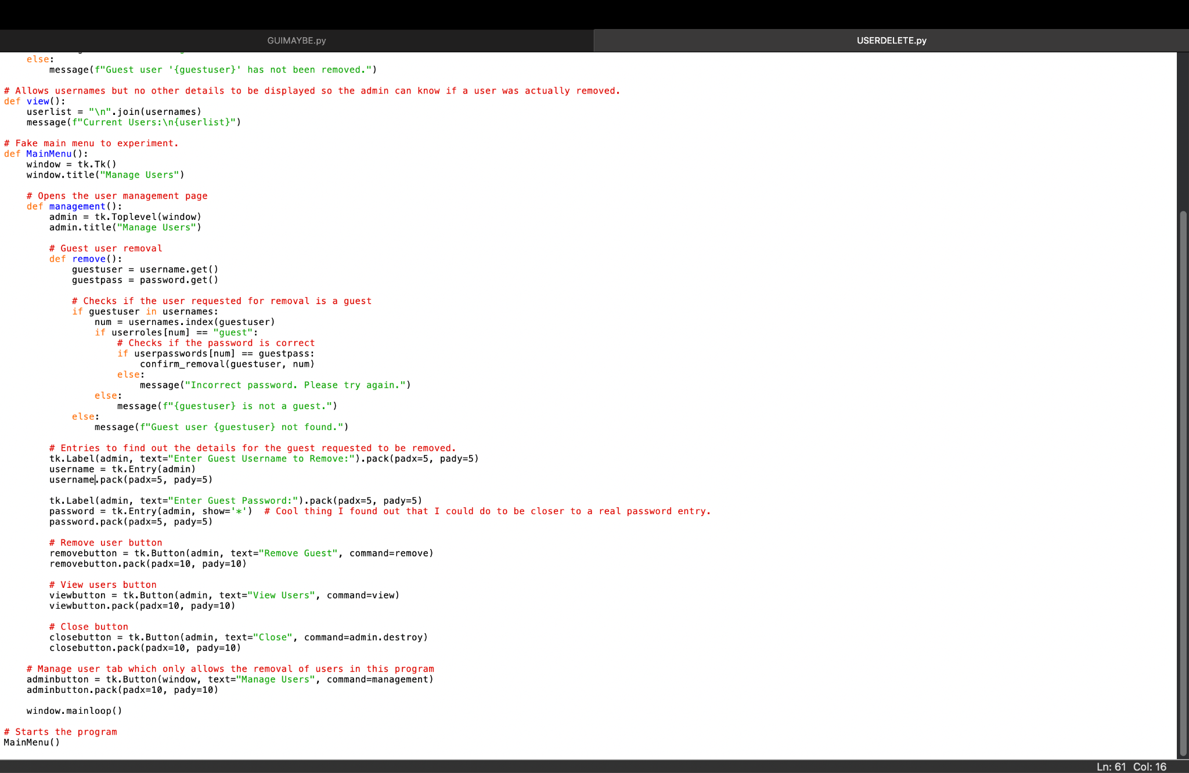

Admin Create Guest User: The *Create Guest User* function intends to create a feature in which a non-admin can create an account to access the warehouse. The entirety of the function operates cohesively. By Utilizing an If, Else Method, the program systematically ensures that the username and password entered by the “guest” have not previously been created. The program can display message boxes after it is provided with the “Tkinter” module.

*Figure 26, First Half of Admin Create Guest User.*

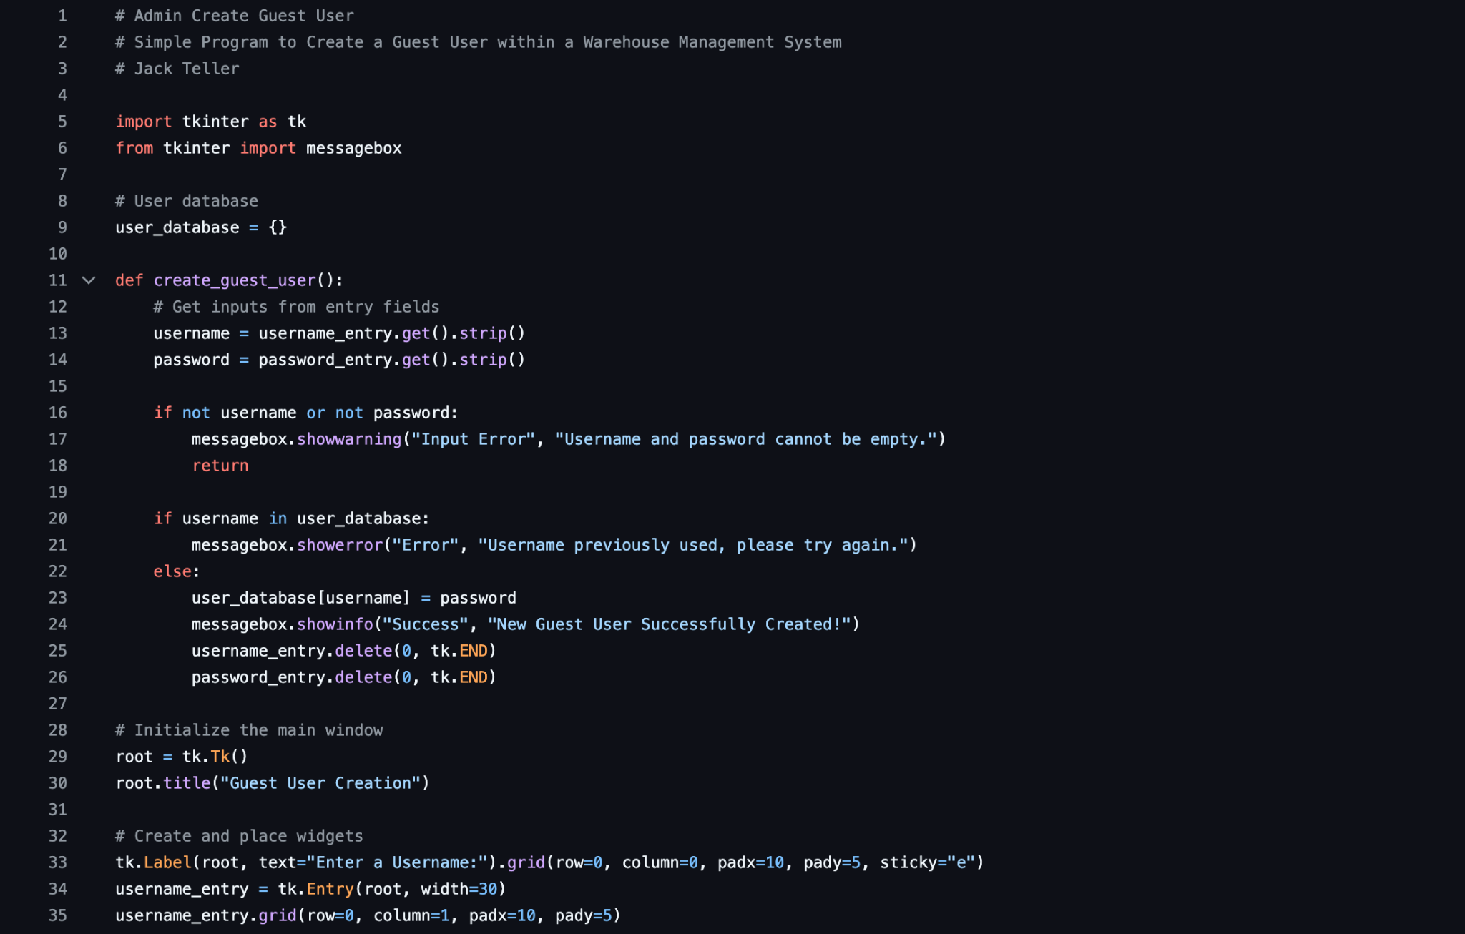

*Figure 27, Second Half of Admin Create Guest User.*

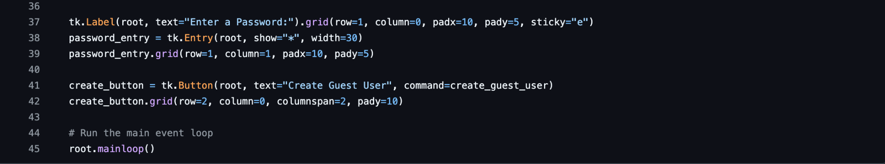

**Data Storage:**

Login Page:

This code creates a CSV file (`users.csv`) and then uses it to store user credentials. Each line in the file represents a username and password pair, separated by a comma (e.g., `admin,1234`). The program reads this data into a Python dictionary (`users`) when it starts, allowing quick in-memory access to validate logins. New users are added both to the dictionary and appended to the CSV file during registration. This method is simple, readable, and portable and since the code creates the file if it doesn’t already exist, there will be no issues running this on a computer that doesn’t already have profiles saved on it.

Admin view Borrow Requests:

This code creates a CSV file (`borrowRequests.csv`) to store borrow requests, each containing ID, Name, Manufacturer, and Status. The program reads this data into a list of dictionaries for in-memory management. Administrators can update request statuses or delete rejected requests, with changes written back to the CSV file. The list of requests can be refreshed and searched by ID, Name, or Manufacturer. The file is created if it doesn't exist, ensuring portability.

User Search:

This code creates a CSV file (User data.csv) to store user data with fields for ID, Name, and Producer. The program reads this data into a list of dictionaries for in-memory searching. Users can search for items by ID, Name, or Producer and display the results. Items can also be added to a favorites list, which is saved in a separate CSV file (favorites.csv). The favorites file is created if it doesn't exist, ensuring portability.

View Favorites Page:

This code reads the CSV file (‘Favorites.csv’) that was created within the regular user search function when a user is prompted to add specific products to their favorite products before returning to the search function. The data is presented in a table that includes the product's name, ID, and producer. Products are only added within the regular user search function and cannot be edited within the view favorites function.

User Buy/Borrow request function:

These functions add a copy of the data presented in the overall list to two CSV files (‘UserHistory.csv’ and ‘BorrowList.csv’) The first file (‘UserHistory.csv’) cannot be edited and is presented on the View History page. This is so the user can view a history of all the items they have requested at any given time. The second file (‘BorrowList.csv’) is viewed by the page admin in the Admin View Requests page, where the admin can approve or deny these requests.

View History Page:

This page reads the CSV file (‘UserHistory.csv’) that is created within the search function any time a user requests to buy or borrow an item from the warehouse. Each line in this file represents the ID of a product, the name of the product, and the producer of the product, each separated by a comma. It is presented in a table on the view history page, and entries cannot be manually added or removed by the user. The file is only edited within the search function when a user requests to buy or borrow an item. This data

Admin Create Guest User Page:

This function adds the user information data (username and password) and stores it in the dictionary *user_database.* When the function is called, it pulls the previous users' information to ensure that the new username and password have not been used prior. It then adds a new key-value pair to the dictionary (The key being the username and the value being the password). All of this ensures the uniqueness of the guest users’ information.

Admin Remove User:

Usernames, roles, and passwords are stored in 3 lists: usernames, userroles, and userpasswords. The admin user can select one of these items to be removed from the list. These items are added to the list when the admin creates a guest user. It is stored in regular lists, and not a CSV file, because we had problems in editing the file. For now, this data storage is a temporary measure. We plan on implementing CSV storage with this file as one of our improvements in the next phase.

Admin Manage Warehouse:

The data is stored in lists titled namelist, pidlist, and producer list. These lists can be edited by the admin user. It is stored in regular lists, and not a CSV file, because we had problems in writing the file. For now, this data storage is a temporary measure. We plan on implementing CSV storage with this file as one of our improvements in the next phase.